7.1 Comparing Two Groups (crazy proof here) p̂             q̂             x̅              y̅

* **Compare means for two populations**
  + Parameter: u1 – u2
  + Statistic: y1 – y2
  + Sampling Distribution: y̅1 - y̅2 
    - Shape: Normal
    - Mean: u1 – u2
    - Std. Dev:
    - Conditions: Samples random, pop normal (CLT if both samples >=30)
* **Compare Prop for two pop**
  + Parameter: p1 – p2
  + Statistic: p̂ 1 – p̂ 2
  + Sampling Distribution: p̂ 1 – p̂ 2
    - Shape: Normal
    - Mean: p̂ 1 – p̂ 2
    - Std. Dev:
    - Conditions: Samples random, large, independent
      * n1p1 , n1(1-p1), n2p2, n2(1-p2) each >=10

7.2 Inference for Means of Two Independent Groups (pg4)

Confidence Interval for Difference in Two Pop Means

* Use: Numeric response variable, a categorical expl. Variable, and 2 categories
* Independent Samples t – test (2 sample test)
* 2 variables | 2 categories
* Paramter: u1 – u2
* CI: 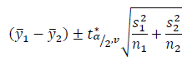
* Dv = 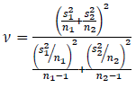
* Conditions: random, pop normal (CLT if n1 and n2 >30), independent
* Test Stat: 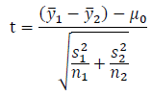
* Pg6 examples

7.3 Pooled Inference for Difference in Means(pg8)

Pooled Inference

* If equal population variances, you can pool the std. dev
* Conditions: random, pop normal , independent AND pop variance =
* Test Stat: 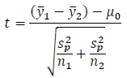 
* Null Dist: t dist w/ dv = n­1 +n2 – 2
* To determine if pop variance =
  + Std Devs are similar
  + Levenes Test: if p-value > sigma you can use the pooled version
* CI: 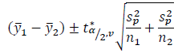

7.4 Inference for Means of Paired Data (pg12)

* Use: when you have 2 linked/paired measurements on a numeric response var
* Paramter ud (population mean difference)
* CI: 
* Df = n -1
* Conditions: random, pop normal or CLT
* Type of Test: Paired t – test
* Test stat: 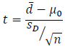
* Null dist: t dist w/ v = n – 1
* Examples pg14

7.5 Inference for Two Proportions (pg19)

* Use: categorical resp. var and categorical expl. Variable w/ 2 categories
* Use: interested in compared proportions for two pop’s
* Paramter: p1 – p2
* CI: 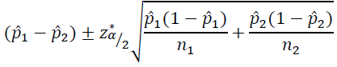
* Multiplier found using Standard normal dist
* Conditions: random, large, independent,
  + n1p1 , n1(1-p1), n2p2, n2(1-p2) each >=10
* Type of Test: 2 sample z test aka independent sample z test
* Null dist: standard normal